
Submitted by : Spogmai Jan
Roll no : 2430 -0081
Submitted to : mam yusra
Dsa lab 07
TASK 01: Write a program to find the maximum value from the doubly linked list and delete it.
Create two functions DeleteNode() and Maxvalue()..
CODE:
#include <iostream>
using namespace std;

// Node structure for doubly linked list
class Node {
public:
int data;
Node* prev;
Node* next;

Node(int value) {
data = value;
prev = NULL;
next = NULL;
}
};

// Doubly Linked List class
class DoublyLinkedList {
private:
Node* head;

public:
// Constructor
DoublyLinkedList() {
head = NULL;
}

// Function to insert node at end
void insertAtEnd(int value) {
Node* newNode = new Node(value);

if (head == NULL) {
head = newNode;
return;
}

Node* temp = head;
while (temp->next != NULL)
temp = temp->next;

temp->next = newNode;
newNode->prev = temp;
}

// Display list forward
void displayForward() {
Node* temp = head;
while (temp != NULL) {
cout << temp->data << " ";
temp = temp->next;
}
cout << endl;
}

// Find node with maximum value
Node* MaxValue() {
if (head == NULL)
return NULL;

Node* temp = head;
Node* maxNode = head;

while (temp != NULL) {
if (temp->data > maxNode->data)
maxNode = temp;
temp = temp->next;
}
return maxNode;
}

// Delete a given node
void DeleteNode(Node* delNode) {
if (head == NULL || delNode == NULL)
return;

if (head == delNode)
head = delNode->next;

if (delNode->next != NULL)
delNode->next->prev = delNode->prev;

if (delNode->prev != NULL)
delNode->prev->next = delNode->next;

delete delNode;
}
};

int main() {
DoublyLinkedList list;

// Create doubly linked list with 7 numbers
for (int i = 1; i <= 7; i++)
list.insertAtEnd(i);

cout << "Original List: ";
list.displayForward();

// Find maximum value
Node* maxNode = list.MaxValue();
if (maxNode != NULL)
cout << "Maximum value is: " << maxNode->data << endl;

// Delete the maximum node
list.DeleteNode(maxNode);

cout << "List after deleting maximum value: ";
list.displayForward();

return 0;
}

OUTPUT:
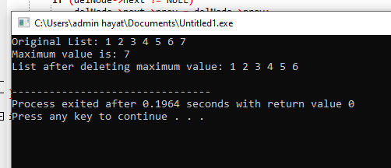

TASK 02:Create double list of 7 numbers with insertion at last, and display the list twice once
forward and once backward.
o Like if list is = [1,2,3,4,5,6,7]
o Output should be = 1 2 3 4 5 6 7 7 6 5 4 3 2 1

CODE:
#include <iostream>
using namespace std;

// Node class for doubly linked list
class Node {
public:
int data;
Node* prev;
Node* next;

Node(int value) {
data = value;
prev = NULL;
next = NULL;
}
};

// Doubly Linked List class
class DoublyLinkedList {
private:
Node* head;

public:
// Constructor
DoublyLinkedList() {
head = NULL;
}

// Insert a node at the end
void insertAtEnd(int value) {
Node* newNode = new Node(value);

if (head == NULL) {
head = newNode;
return;
}

Node* temp = head;
while (temp->next != NULL)
temp = temp->next;

temp->next = newNode;
newNode->prev = temp;
}

// Display list forward
void displayForward() {
Node* temp = head;
while (temp != NULL) {
cout << temp->data << " ";
temp = temp->next;
}
}

// Display list backward
void displayBackward() {
if (head == NULL) return;

// Move to the last node
Node* temp = head;
while (temp->next != NULL)
temp = temp->next;

// Now print backward
while (temp != NULL) {
cout << temp->data << " ";
temp = temp->prev;
}
}

// Function to display both directions in one line
void displayBoth() {
displayForward(); // forward
displayBackward(); // backward
cout << endl;
}
};

// ---------------- Main function ----------------
int main() {
DoublyLinkedList list;

// Create list of 7 numbers
for (int i = 1; i <= 7; i++)
list.insertAtEnd(i);

cout << "Output: ";
list.displayBoth(); // forward and backward in one line

return 0;
}
OUTPUT:
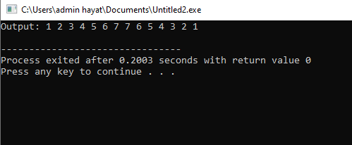
TASK 03: Circular Linked List. A circular linked list, is a linked list in which a tail node points to
the head node, forming a circular path.
o Write all the required functions to create a single circular list.
o Make a function displayList(), to print all of its nodes.
CODE:
#include <iostream>
using namespace std;

// Node class for Circular Linked List
class Node {
public:
int data;
Node* next;

Node(int value) {
data = value;
next = NULL;
}
};

// Circular Linked List class
class CircularLinkedList {
private:
Node* head;

public:
// Constructor
CircularLinkedList() {
head = NULL;
}

// Function to insert node at the end
void insertAtEnd(int value) {
Node* newNode = new Node(value);

if (head == NULL) {
head = newNode;
head->next = head; // circular link
return;
}

Node* temp = head;
while (temp->next != head) {
temp = temp->next;
}

temp->next = newNode;
newNode->next = head; // link back to head
}

// Function to display the circular list
void displayList() {
if (head == NULL) {
cout << "List is empty." << endl;
return;
}

Node* temp = head;
do {
cout << temp->data << " ";
temp = temp->next;
} while (temp != head);

cout << endl;
}

// Optional: Function to count nodes (for understanding)
int countNodes() {
if (head == NULL)
return 0;

int count = 0;
Node* temp = head;
do {
count++;
temp = temp->next;
} while (temp != head);

return count;
}
};

// ---------------- Main function ----------------
int main() {
CircularLinkedList clist;

// Insert 5 nodes into circular linked list
for (int i = 1; i <= 5; i++)
clist.insertAtEnd(i);

cout << "Circular Linked List: ";
clist.displayList();

cout << "Total nodes in list: " << clist.countNodes() << endl;

return 0;
}

OUTPUT:



